Mata Kuliah | : | Pemrograman Web Lanjut (PWL)
Program Studi | : | D4 – Teknik Informatika
Semester | : | 4
Kelas | : | TI 2A
NIM | : | 244107020240
Nama | : | Mochammad Rijal Dzaki Rifki Afifudin
Jobsheet Ke- | : | 4
GitHub | : | https://github.com/Zinc-zn/14_PWL

Laporan Jobsheet

- Praktikum 1 - fillable
Langkah | Jawaban/Deskripsi
1 | Modifikasi UserModel.php  <?php  namespace App\Models;  use Illuminate\Database\Eloquent\Factories\HasFactory;  use Illuminate\Database\Eloquent\Model;  class UserModel extends Model  {  use HasFactory;  protected $table = 'm_user';  protected $primaryKey = 'user_id';  protected $fillable = ['level_id', 'username', 'nama', 'password'];  }  Modifikasi UserController.php  <?php  namespace App\Http\Controllers;  use App\Models\UserModel;  use Illuminate\Http\Request;  use Illuminate\Support\Facades\Hash;  class UserController extends Controller  {  public function index()  {  $data = [  'level_id' => 2,  'username' => 'manager dua',  'nama' => 'Manager 2',  'password' => Hash::make('12345')  ];  UserModel::create($data);  $user = UserModel::all();  return view('user', ['data' => $user]);  }  }  Modifikasi User.blade.php  <!DOCTYPE html>  <html lang="en">  <head>  <meta charset="UTF-8">  <meta name="viewport" content="width=device-width, initial-scale=1.0">  <title>Data User</title>  </head>  <body>  <h1>Data User</h1>  <table border="1" cellpadding="2" cellspacing="0">  <tr>  <th>ID</th>  <th>Username</th>  <th>Nama</th>  <th>ID Level Pengguna</th>  </tr>  @foreach ($data as $d)  <tr>  <td>{{ $d->user_id }}</td>  <td>{{ $d->username }}</td>  <td>{{ $d->nama }}</td>  <td>{{ $d->level_id }}</td>  </tr>  @endforeach  </table>  </body>  </html>  Hasil:  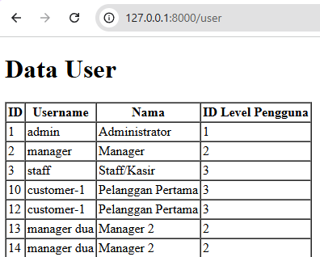
2 | Modifikasi UserModel.php:  <?php  namespace App\Models;  use Illuminate\Database\Eloquent\Factories\HasFactory;  use Illuminate\Database\Eloquent\Model;  class UserModel extends Model  {  use HasFactory;  protected $table = 'm_user';  protected $primaryKey = 'user_id';  protected $fillable = ['level_id', 'username', 'nama'];  }  Modifikasi UserController.php:  <?php  namespace App\Http\Controllers;  use App\Models\UserModel;  use Illuminate\Http\Request;  use Illuminate\Support\Facades\Hash;  class UserController extends Controller  {  public function index()  {  $data = [  'level_id' => 2,  'username' => 'manager_tiga',  'nama' => 'Manager 3',  'password' => Hash::make('12345')  ];  UserModel::create($data);  $user = UserModel::all();  return view('user', ['data' => $user]);  }  }  Hasil:  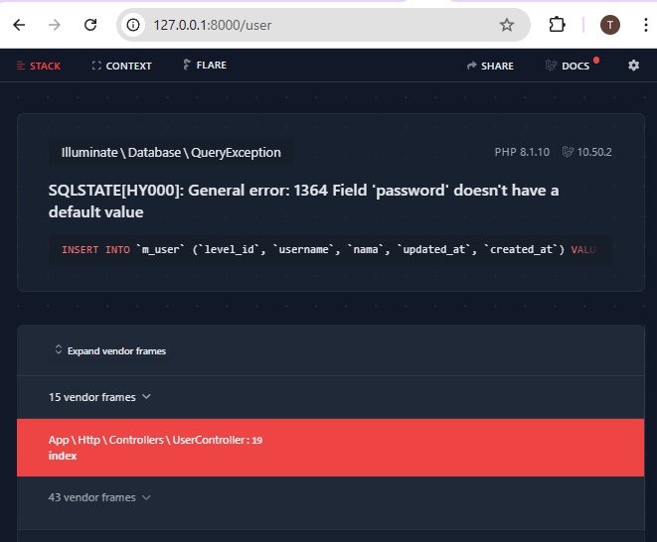  Perbaikan:  Menambahkan password pada UserModels.php  <?php  namespace App\Models;  use Illuminate\Database\Eloquent\Factories\HasFactory;  use Illuminate\Database\Eloquent\Model;  class UserModel extends Model  {  use HasFactory;  protected $table = 'm_user';  protected $primaryKey = 'user_id';  protected $fillable = ['level_id', 'username', 'nama', 'password'];  }  Hasil:  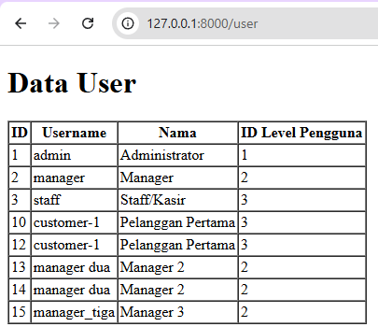

- Praktikum 2.1 - Retrieving Single Models
Langkah | Jawaban/Deskripsi
1 | Modifikasi UserController.php  <?php  namespace App\Http\Controllers;  use App\Models\UserModel;  use Illuminate\Http\Request;  use Illuminate\Support\Facades\Hash;  class UserController extends Controller  {  public function index()  {  $user = UserModel::find(1);  return view('user', ['data' => $user]);  }  }  Modifikasi User.blade.php  <!DOCTYPE html>  <html lang="en">  <head>  <meta charset="UTF-8">  <meta name="viewport" content="width=device-width, initial-scale=1.0">  <title>Data User</title>  </head>  <body>  <h1>Data User</h1>  <table border="1" cellpadding="2" cellspacing="0">  <tr>  <th>ID</th>  <th>Username</th>  <th>Nama</th>  <th>ID Level Pengguna</th>  </tr>  <tr>  <td>{{ $data->user_id }}</td>  <td>{{ $data->username }}</td>  <td>{{ $data->nama }}</td>  <td>{{ $data->level_id }}</td>  </tr>  </table>  </body>  </html>  Hasil:  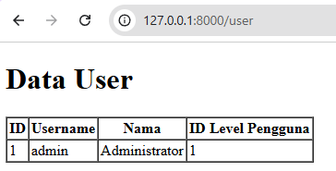
2 | Modifikasi UserController.php  <?php  namespace App\Http\Controllers;  use App\Models\UserModel;  use Illuminate\Http\Request;  use Illuminate\Support\Facades\Hash;  class UserController extends Controller  {  public function index()  {  $user = UserModel::where('level_id', 1)->first();  return view('user', ['data' => $user]);  }  }  Hasil:  
3 | Modifikasi UserController.php  <?php  namespace App\Http\Controllers;  use App\Models\UserModel;  use Illuminate\Http\Request;  use Illuminate\Support\Facades\Hash;  class UserController extends Controller  {  public function index()  {  $user = UserModel::firstWhere('level_id', 1);  return view('user', ['data' => $user]);  }  }  Hasil:  
4 | Modifikasi UserController.php  <?php  namespace App\Http\Controllers;  use App\Models\UserModel;  use Illuminate\Http\Request;  use Illuminate\Support\Facades\Hash;  class UserController extends Controller  {  public function index()  {  $user = UserModel::findOr(1, ['username', 'nama'], function() {  abort(404);  });  return view('user', ['data' => $user]);  }  }  Hasil:  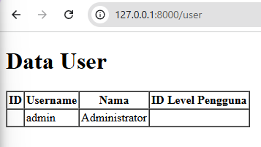
5 | Modifikasi UserController.php  <?php  namespace App\Http\Controllers;  use App\Models\UserModel;  use Illuminate\Http\Request;  use Illuminate\Support\Facades\Hash;  class UserController extends Controller  {  public function index()  {  $user = UserModel::findOr(20, ['username', 'nama'], function() {  abort(404);  });  return view('user', ['data' => $user]);  }  }  Hasil:  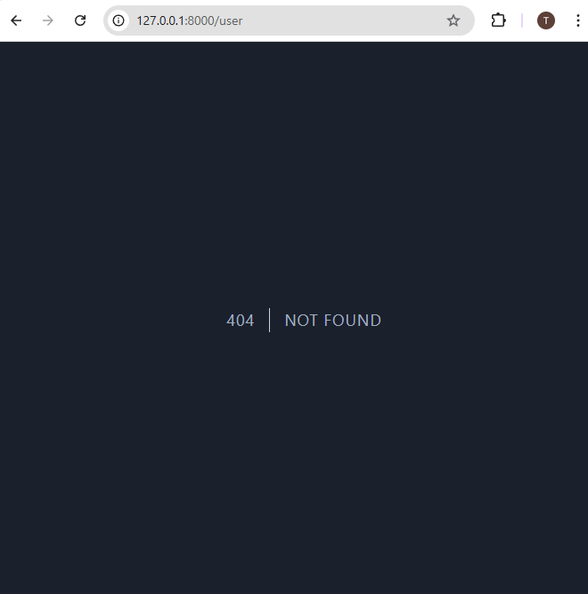

- Praktikum 2.2 - Not Found Exceptions
Langkah | Jawaban/Deskripsi
1 | Modifikasi UserController.php  <?php  namespace App\Http\Controllers;  use App\Models\UserModel;  use Illuminate\Http\Request;  use Illuminate\Support\Facades\Hash;  class UserController extends Controller  {  public function index()  {  $user = UserModel::findOrFail(1);  return view('user', ['data' => $user]);  }  }  Hasil:  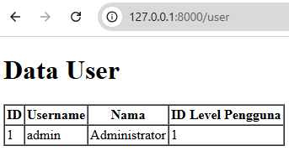
2 | Modifikasi UserController.php  <?php  namespace App\Http\Controllers;  use App\Models\UserModel;  use Illuminate\Http\Request;  use Illuminate\Support\Facades\Hash;  class UserController extends Controller  {  public function index()  {  $user = UserModel::where('username', 'manager9')->findOrFail();  return view('user', ['data' => $user]);  }  }  Hasil:  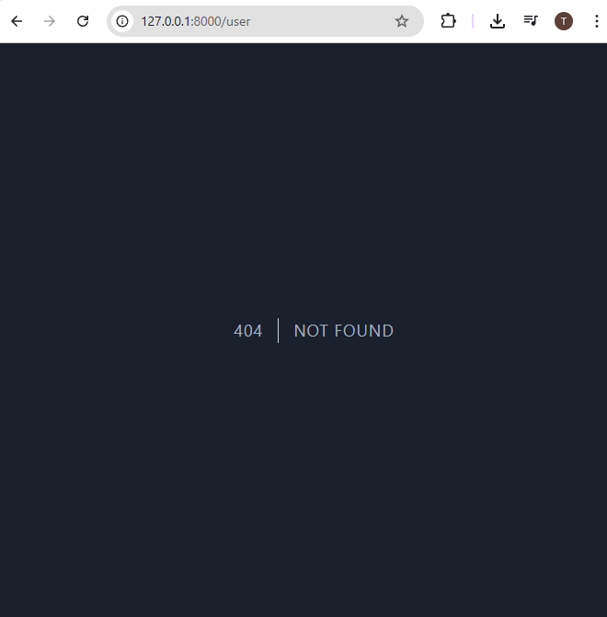

- Praktikum 2.3 - Retreiving Aggregrates
Langkah | Jawaban/Deskripsi
1 | Modifikasi UserConctroller.php  <?php  namespace App\Http\Controllers;  use App\Models\UserModel;  use Illuminate\Http\Request;  use Illuminate\Support\Facades\Hash;  class UserController extends Controller  {  public function index()  {  $user = UserModel::where('level_id', 2)->count();  return view('user', ['data' => $user]);  }  }  Modifikasi User.blade.php  <!DOCTYPE html>  <html lang="en">  <head>  <meta charset="UTF-8">  <meta name="viewport" content="width=device-width, initial-scale=1.0">  <title>Data User</title>  </head>  <body>  <h1>Data User</h1>  <table border="1" cellpadding="2" cellspacing="0">  <tr>  <th>Jumlah Pengguna</th>  </tr>  <tr>  <td>{{ $data }}</td>  </tr>  </table>  </body>  </html>  Hasil:  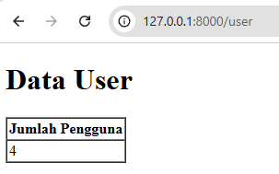
- Praktikum 2.4 - Retreiving or Creating Models
Langkah | Jawaban/Deskripsi
1 | Modifikasi UserConctroller.php  <?php  namespace App\Http\Controllers;  use App\Models\UserModel;  use Illuminate\Http\Request;  use Illuminate\Support\Facades\Hash;  class UserController extends Controller  {  public function index()  {  $user = UserModel::firstOrCreate(  [  'username' => 'manager',  'nama' => 'Manager',  ],  );  return view('user', ['data' => $user]);  }  }  Modifikasi User.blade.php:  <!DOCTYPE html>  <html lang="en">  <head>  <meta charset="UTF-8">  <meta name="viewport" content="width=device-width, initial-scale=1.0">  <title>Data User</title>  </head>  <body>  <h1>Data User</h1>  <table border="1" cellpadding="2" cellspacing="0">  <tr>  <th>ID</th>  <th>Username</th>  <th>Nama</th>  <th>ID Level Pengguna</th>  </tr>  <tr>  <td>{{ $data->user_id }}</td>  <td>{{ $data->username }}</td>  <td>{{ $data->nama }}</td>  <td>{{ $data->level_id }}</td>  </tr>  </table>  </body>  </html>  Hasil:  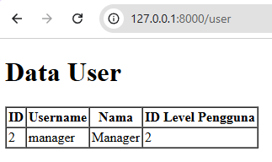
2 | Modifikasi UserController.php  <?php  namespace App\Http\Controllers;  use App\Models\UserModel;  use Illuminate\Http\Request;  use Illuminate\Support\Facades\Hash;  class UserController extends Controller  {  public function index()  {  $user = UserModel::firstOrCreate(  [  'username' => 'manager22',  'nama' => 'Manage Dua Dua',  'password' => Hash::make('12345'),  'level_id' => 2  ],  );  return view('user', ['data' => $user]);  }  }  Hasil:  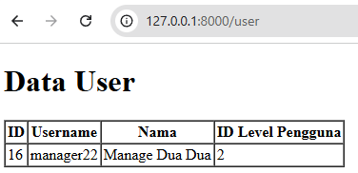
3 | Modifikasi UserController.php  <?php  namespace App\Http\Controllers;  use App\Models\UserModel;  use Illuminate\Http\Request;  use Illuminate\Support\Facades\Hash;  class UserController extends Controller  {  public function index()  {  $user = UserModel::firstOrCreate(  [  'username' => 'manager',  'nama' => 'Manager',  ],  );  return view('user', ['data' => $user]);  }  }  Hasil:  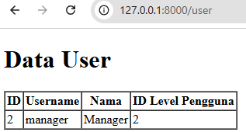
4 | Modifikasi UserController.php:  <?php  namespace App\Http\Controllers;  use App\Models\UserModel;  use Illuminate\Http\Request;  use Illuminate\Support\Facades\Hash;  class UserController extends Controller  {  public function index()  {  $user = UserModel::firstOrCreate(  [  'username' => 'manager33',  'nama' => 'Manager Tiga Tiga',  'password' => Hash::make('12345'),  'level_id' => 2  ],  );  return view('user', ['data' => $user]);  }  }  Hasil:  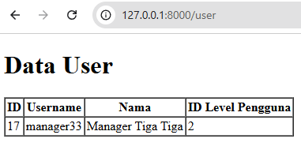
5 | Modifikasi UserController.php  <?php  namespace App\Http\Controllers;  use App\Models\UserModel;  use Illuminate\Http\Request;  use Illuminate\Support\Facades\Hash;  class UserController extends Controller  {  public function index()  {  $user = UserModel::firstOrCreate(  [  'username' => 'manager33',  'nama' => 'Manager Tiga Tiga',  'password' => Hash::make('12345'),  'level_id' => 2  ],  );  $user->save();  return view('user', ['data' => $user]);  }  }  Hasil:  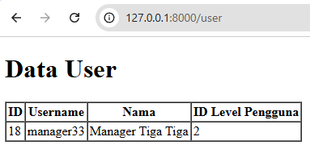

- Praktikum 2.5 - Attribute Changes
Langkah | Jawaban/Deskripsi
1 | Modifikasi UserConctroller.php  <?php  namespace App\Http\Controllers;  use App\Models\UserModel;  use Illuminate\Http\Request;  use Illuminate\Support\Facades\Hash;  class UserController extends Controller  {  public function index()  {  $user = UserModel::create([  'username' => 'manager55',  'nama' => 'Manager55',  'password' => Hash::make('12345'),  'level_id' => 2  ]);  $user->username = 'manager56';  dump($user->isDirty());  dump($user->isDirty('username'));  dump($user->isDirty('nama'));  dump($user->isDirty(['nama', 'username']));  dump($user->isClean());  dump($user->isClean('username'));  dump($user->isClean('nama'));  dump($user->isClean(['nama', 'username']));  $user->save();  dd($user->isDirty());  }  }  Hasil:  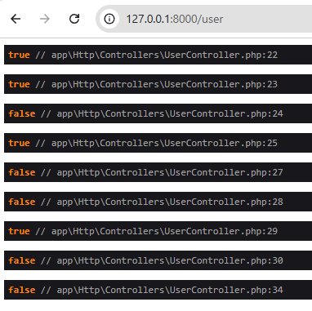
2 | Modifikasi UserController.php  <?php  namespace App\Http\Controllers;  use App\Models\UserModel;  use Illuminate\Http\Request;  use Illuminate\Support\Facades\Hash;  class UserController extends Controller  {  public function index()  {  $user = UserModel::create([  'username' => 'manager11',  'nama' => 'Manager11',  'password' => Hash::make('12345'),  'level_id' => 2,  ]);  $user->username = 'manager12';  $user->save();  $user->wasChanged();  $user->wasChanged('username');  $user->wasChanged(['username', 'level_id']);  $user->wasChanged('nama');  $user->wasChanged(['nama', 'username']);  }  }  Hasil:  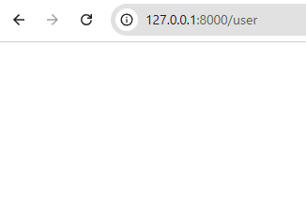
3 | Modifikasi UserController.php  <?php  namespace App\Http\Controllers;  use App\Models\UserModel;  use Illuminate\Http\Request;  use Illuminate\Support\Facades\Hash;  class UserController extends Controller  {  public function index()  {  $user = UserModel::create([  'username' => 'manager11',  'nama' => 'Manager11',  'password' => Hash::make('12345'),  'level_id' => 2,  ]);  $user->username = 'manager12';  $user->save();  $user->wasChanged();  $user->wasChanged('username');  $user->wasChanged(['username', 'level_id']);  $user->wasChanged('nama');  $user->wasChanged(['nama', 'username']);  dd($user->wasChanged(['nama', 'username']));  }  }  Hasil:  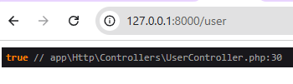

- Praktikum 2.6 - Create, Read, Update, Delete (CRUD)
Langkah | Jawaban/Deskripsi
1 | Modifikasi User.blade.php  <!DOCTYPE html>  <html lang="en">  <head>  <meta charset="UTF-8">  <meta name="viewport" content="width=device-width, initial-scale=1.0">  <title>Data User</title>  </head>  <body>  <h1>Data User</h1>  <table border="1" cellpadding="2" cellspacing="0">  <tr>  <th>ID</th>  <th>Username</th>  <th>Nama</th>  <th>ID Level Pengguna</th>  <th>Aksi</th>  </tr>  @foreach ($data as $d )  <tr>  <td>{{ $d->user_id }}</td>  <td>{{ $d->username }}</td>  <td>{{ $d->nama }}</td>  <td>{{ $d->level_id }}</td>  <td><a href="/user/ubah/{{$d->user_id}}"Ubah></a> | <a href="/user/habus{{ $d->user_id }}">Hapus</a></td>  </tr>  @endforeach  </table>  </body>  </html>  Modifikasi UserController.php  <?php  namespace App\Http\Controllers;  use App\Models\UserModel;  use Illuminate\Http\Request;  use Illuminate\Support\Facades\Hash;  class UserController extends Controller  {  public function index()  {  $user = UserModel::all();  return view('user', ['data' => $user]);  }  }  Hasil:  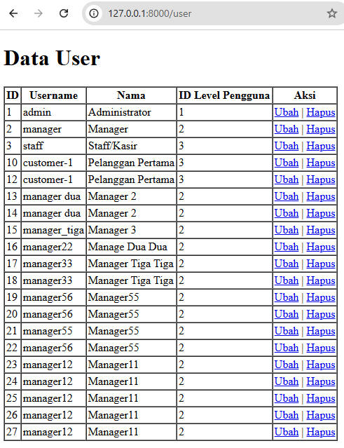
2 | Membuat file baru bernama “user_tambah.blade.php”, dan tulis syntax berikut:  <!DOCTYPE html>  <html lang="en">  <head>  <meta charset="UTF-8">  <meta name="viewport" content="width=device-width, initial-scale=1.0">  <title>User Tambah</title>  </head>  <body>  <h1>Form Tambah Data User</h1>  <form method="post" action="/user/tambah_simpan">  {{ csrf_field() }}  <label>Username</label>  <input type="text" name="username" placeholder="Masukan Username">  <br>  <label>Nama</label>  <input type="text" name="nama" placeholder="Masukan Nama">  <br>  <label>Password</label>  <input type="password" name="password" placeholder="Masukan Password">  <br>  <label>Level ID</label>  <input type="number" name="level_id" placeholder="Masukan ID Level">  <br><br>  <input type="submit" class="btn btn-success" value="Simpan">  </form>  </body>  </html>  Tambahkan Syntax berikut pada web.php  Route::get('/user/tambah', [UserController::class,'index']);  Tambahkan Syntax berikut pada userController.php  public function tambah()  {  return view('user_tambah');  }  Hasil:  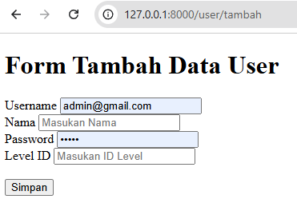
3 | Tambahkan Syntax berikut pada web.hp  Route::get('/user/tambah_simpan', [UserController::class,'tambah_simpan']);  Tambahkan Syntax berikut pada UserController.php  public function tambah_simpan(Request $request)  {  UserModel::create([  'username' => $request->username,  'nama' => $request->nama,  'password' => Hash::make('$request->password'),  'level_id' => $request->level_id  ]);  return redirect('/user');  }  Hasil:  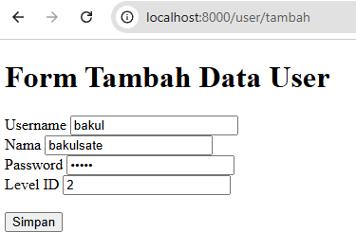  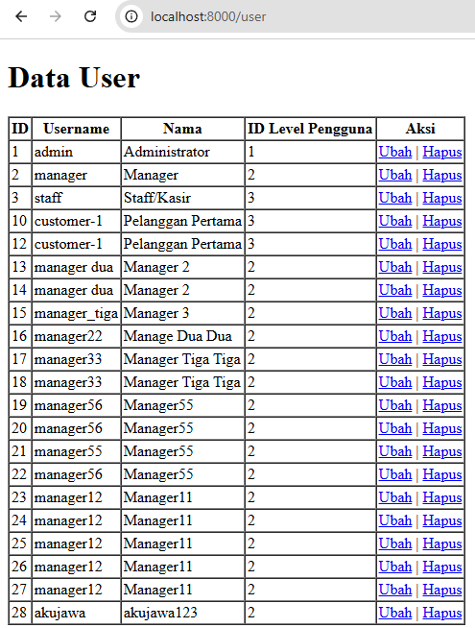
4 | Membuat file baru bernama “user_ubah.blade.php” dan tuliskan syntax berikut:  <!DOCTYPE html>  <html lang="en">  <head>  <meta charset="UTF-8">  <meta name="viewport" content="width=device-width, initial-scale=1.0">  <title>User Ubah</title>  </head>  <body>  <h1>Form Ubah Data User</h1>  <a href="/user">Kembali</a>  <br><br>  <form method="post" action="/user/ubah_simpan/{{ $data->user_id }}">  {{ csrf_field() }}  {{ method_field('PUT') }}  <label>Username</label>  <input type="text" name="username" placeholder="Masukan Username" value="{{ $data->username }}">  <br>  <label>Nama</label>  <input type="text" name="nama" placeholder="Masukan Nama" value="{{ $data->username }}">  <br>  <label>Password</label>  <input type="password" name="password" placeholder="Masukan Password" value="{{ $data->password }}">  <br>  <label>Level ID</label>  <input type="number" name="level_id" placeholder="Masukan ID Level" value="{{ $data->level_id }}">  <br><br>  <input type="submit" class="btn btn-success" value="Ubah">  </form>  </body>  </html>  Tambahkan Syntax berikut pada web.php  Route::get('/user/ubah/{id}', [UserController::class,'ubah']);  Tambahkan syntax berikut pada UserController.php  public function ubah($id)  {  $user = UserModel::find($id);  return view('user_ubah', ['data' => $user]);  }  Hasil:  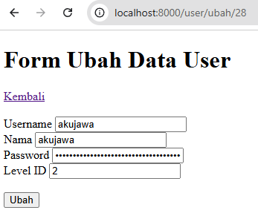
5 | Tambahkan syntax berikut pada web.php  Route::put('/user/ubah_simpan/{id}', [UserController::class,'ubah_simpan']);  Tambahkan syntax berikut pada UserController.php  public function ubah_simpan($id, Request $request)  {  $user = UserModel::find($id);  $user->username = $request->username;  $user->nama = $request->nama;  $user->password = Hash::make('$request->password');  $user->level_id = $request->level_id;  $user->save();  return redirect('/user');  }  Hasil:  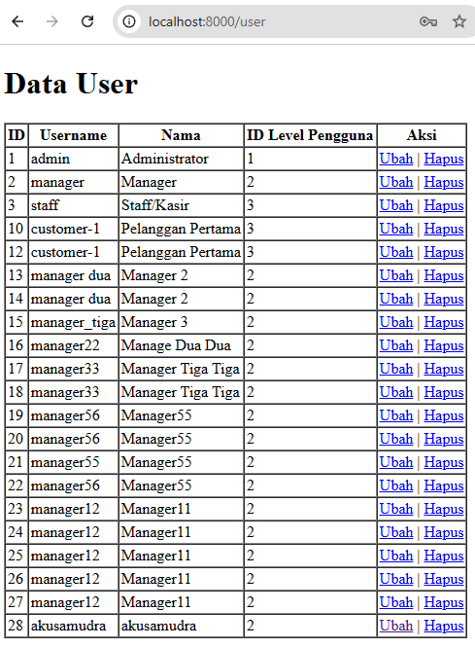  Sebelumnya “akujawa”, sekarang berubah menjadi “akusamudra”
6 | Tambahkan Syntax berikut pada web.php  Route::get('/user/hapus/{id}', [UserController::class,'hapus']);  Tambahkan Syntax berikut pada UserController.php  public function hapus($id)  {  $user = USerModel::find($id);  $user->delete();  return redirect('/user');  }  Hasil:  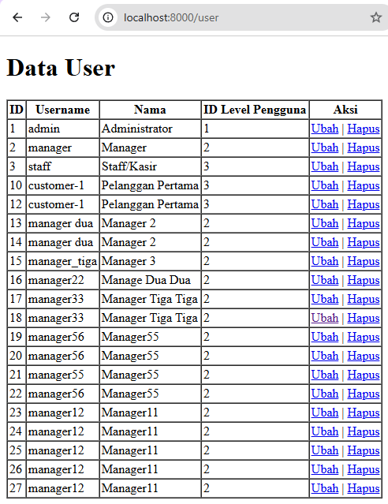

- Praktikum 2.7 - Relationships
Langkah | Jawaban/Deskripsi
1 | Membuat LevelModel dan ketikan syntax berikut:  <?php  namespace App\Models;  use Illuminate\Database\Eloquent\Factories\HasFactory;  use Illuminate\Database\Eloquent\Model;  use Illuminate\Database\Eloquent\Relations\BelongsTo;  class LevelModel extends Model  {  public function user(): BelongsTo  {  return $this->belongsTo(UserModel::class);  }  }  Membuat KategoriModel dan ketikan syntax berikut:  <?php  namespace App\Models;  use Illuminate\Database\Eloquent\Factories\HasFactory;  use Illuminate\Database\Eloquent\Model;  use Illuminate\Database\Eloquent\Relations\HasMany;  class KategoriModel extends Model  {  public function barang():HasMany  {  return $this->hasMany(BarangModel::class, 'barang_id', 'barang_id');  }  }  Membuat BarangModel, dan ketikan syntax berikut:  <?php  namespace App\Models;  use Illuminate\Database\Eloquent\Factories\HasFactory;  use Illuminate\Database\Eloquent\Model;  use Illuminate\Database\Eloquent\Relations\BelongsTo;  class BarangModel extends Model  {  public function kategori():BelongsTo  {  return $this->belongsTo(KategoriModel::class,'kategori_id', 'kategori_id');  }  }  Tambahkan syntax berikut pada UserModel:  public function level(): BelongsTo  {  return $this->belongsTo(LevelModel::class, 'level_id', 'level_id');  }  Modifikasi userController menjadi seperti ini:  public function index()  {  $user = UserModel::with('level')->get();  dd($user);  }  Modifikasi userController menjadi seperti ini:  public function index()  {  $user = UserModel::with('level')->get();  return view('user', ['data' => $user]);  }  Modifikasi user.blade.php menajadi seperti ini:  <!DOCTYPE html>  <html lang="en">  <head>  <meta charset="UTF-8">  <meta name="viewport" content="width=device-width, initial-scale=1.0">  <title>Data User</title>  </head>  <body>  <h1>Data User</h1>  <a href="/user/tambah">+ Tambah User</a>  <table border="1" cellpadding="2" cellspacing="0">  <tr>  <td>ID</td>  <td>Username</td>  <td>Nama</td>  <td>ID Level Pengguna</td>  <td>Kode Level</td>  <td>Nama Level</td>  <td>Aksi</td>  </tr>  @foreach ($data as $d)  <tr>  <td>{{ $d->user_id }}</td>  <td>{{ $d->username }}</td>  <td>{{ $d->nama }}</td>  <td>{{ $d->level_id }}</td>  <td>{{ $d->level->level_kode }}</td>  <td>{{ $d->level->level_nama }}</td>  <td>  <a href="/user/ubah/{{ $d->user_id }}">Ubah</a> |  <a href="/user/hapus/{{ $d->user_id }}">Hapus</a>  </td>  </tr>  @endforeach  </table>  </body>  </html>  Hasil:

